National ASK (Asking Saves Kids) Day and Goods for Guns- Gun Buyback

Receive groceries gift cards for each gun
$25 for rifle; $50 for pistol; $75 for automatic or semi-automatic
Gun Lock Giveaway
Get gun locks for free, even if you aren’t turning in a gun!

Date: Saturday, June 23, 2018
Time: 12- 3pm
Place: Unitarian Universalist Church of Worcester
90 Holden Street
Worcester, MA

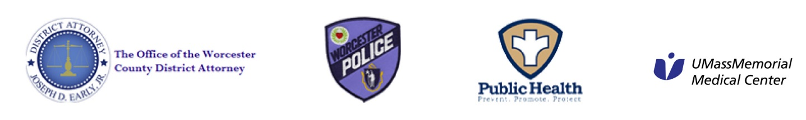
A message from City of Worcester Medical Director, Dr. Michael Hirsh:
An unsecured weapon in the home is a public health danger that leads to more frequent homicides, burglaries, lethal domestic violence, accidental shootings and suicide in the home.
Please honor the memories of all our citizens, young and old, harmed by gun violence by bringing in your unwanted/unsecured weapon(s) (unloaded please) in a plain plastic or paper bag.

